Germany Energy Redeployment
By: Mariam Sendali

Introduction

Both the roots and the consequences of the energy crisis that unfolded in Germany in 2022 need to be seen from a political and historical perspective. Despite the tensions of the cold war era, Russia's hydrocarbons continued to be imported into Europe, which spared Germany the financial burden of constructing expensive liquefied natural gas terminals and other infrastructure required to handle alternative sources of energy imports. Today Germany can be subject of analysis of a western democratic state that took a calculated risk by embracing globalization and interconnectedness but is currently experiencing the negative outcomes of that decision.

Despite the fact that Germany has been undergoing an energy transition, known as the "Energiewende", since the 1990s, aiming to shift away from nuclear power and fossil fuels towards a more sustainable and renewable energy system, the country’s energy mix as of 2022 was heavily reliant on oil and gas. The latter, used both for electricity generation and as a heating fuel also was for a long time considered as a bridging fuel in the transition away from coal and nuclear power. Both coal-fired and nuclear power plants have been gradually phased out in response to public concerns about safety and environmental risks.
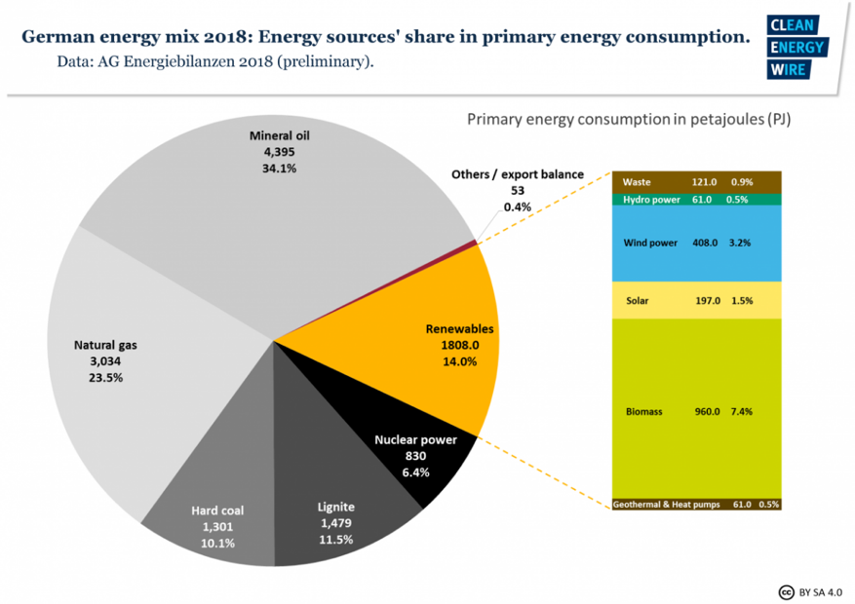

Figure 1: German energy mix in 2018
Source: Clean Energy Wire, 18. 04.2023
https://www.cleanenergywire.org/news/significant-drop-energy-use-pushes-down-german-emissions-2018

The high level of German energy needs is associated with the fact that the country possesses the largest industry in Europe. Some industrial sectors in Germany, such as steel, cement, and chemical industries have a higher share of fossil fuel usage due to the high-temperature processes required for their production. In these sectors, coal, natural gas, and some oil derivatives are still used as feedstocks or energy sources.

That said, in 2020, Germany's energy import dependency stood at 63.7 percent, positioning the country as one of the largest importers of natural gas globally. Approximately 95 percent of its gas consumption and about 98 percent of primary mineral oil consumption were met through imports. Notably, 55 percent of gas imports originated from Russia, while 30 percent came from Norway, and 13 percent from the Netherlands. Oil imports, being more diversified, still relied on Russia with 28.6 percent of imports.

This reliance on Russian gas has created a path dependency, where existing infrastructure and long-term supply contracts made it challenging to shift away from this energy source quickly. In its turn, Germany's energy infrastructure, including pipelines and import terminals, has been built to accommodate Russian gas imports - which has contributed to path dependency and complicated potential adaptation or replacement of the facilities to accommodate other energy sources. After all, Germany's strong economic and political ties with Russia, have created interdependencies that also strongly influenced political decisions until 2022 and ended up limiting the country's ability to respond assertively to certain geopolitical issues.

Breaking a path dependence like the one Germany used to have in place seemed an impossible task in the beginning of the crisis. The scale of dependency and the scale of the industry being dependent were incomparable to the situation in the neighboring countries. Today with the industry hoping that the government will do what’s needed to keep it alive and the people apprehensive of high energy prices and lack of electricity, the German government in fact had indeed faced with the task of an increased complexity. In this paper we will examine both the initial historical situation in which Germany found itself in 2022 and the political and economic response of the government during 2022.

Legacy of the past
For more than the last three centuries, Russian-German relations have been a focal point of European politics. Although they have been allies on numerous occasions, they have also engaged in two wars against each other in the twentieth century. In World War II, Adolf Hitler's attack on the Soviet Union ultimately led to Nazi Germany's defeat, giving the Soviet Union dominance over half of Europe and Germany, and making it a nuclear superpower. Even now, the legacy of World War II which resulted in the deaths of 28 million Soviet citizens, is a cornerstone of Russia's global status and moral authority, as well as a fundamental aspect of its contemporary identity. For Germany, too, the end of World War II and the demise of the Third Reich became a watershed event, which helped mold a new German identity based on the rule of law, market economics, respect for humanity, tolerance, and restraint in the use of military force.

One of the prominent examples of Russian (Soviet) – German (GDR) energy ties is the PCK oil refinery. The town Schwedt in the land of Brandenburg was almost completely destroyed in the Soviet advance during the second world war. Then in the 1950s, young people from all over East Germany converged on Schwedt to rebuild the town and build the refinery. The pipeline carries crude some 4,000km from Almetyevsk in central Russia. Soon after it came online in 1964, PCK established itself as the region’s main supplier of petrol, diesel, jet kerosene, and fuel oil. The story of PCK will have a crucial turn in 2022 as we see later in this paper.

In 1973, Russia fully established its energy relations with West Germany as with the start of gas exports to the country. In the early 1970s, the policy introduced by Brandt was known as Neue Ostpolitik, which translates to "New Eastern Policy." The term "Wandel durch Handel," which means "change through trade," was derived from an earlier formulation by Egon Bahr, who coined the phrase "Wandel durch Annährung," or "change through rapprochement." This concept marked the initial shift in West Germany's approach towards the Soviet Union, moving from a position of strength to one of dialogue. A dogma was established in the gas industry: Germany did not have a dependency issue concerning Russian natural gas. "We aren't susceptible to blackmail," another German Chancellor Helmut Kohl intoned in 1983.

The approaching end of the Cold War, which led to the reunification of Germany in 1990, marked a crucial turning point. Moscow's backing of German reunification under the auspices of the Federal Republic of Germany was a significant symbol of historical reconciliation, forty-five years after the deadliest war in the history of both nations. Following the reunification of Germany in the early 1990s, the dissolution of the Soviet Union in 1991 did not impede the progression of German-Russian relations. Instead, bilateral relations started to flourish across a wide range of fields and at various levels.

Since the 1990s, Gazprom, the Russian state natural gas company, has shown a growing interest in supplying gas to Europe without transiting Ukraine, due to Ukraine's inadequate gas infrastructure and geopolitical considerations. The Yamal pipeline, which was completed in 2006, connected Siberian gas fields with Germany via Belarus and Poland, and soon reached its full capacity. In due course, the Nord Stream 1 pipeline proposal emerged, which aimed to transport gas directly from Russian territory to German territory via the Baltic Sea, bypassing all intermediary countries.
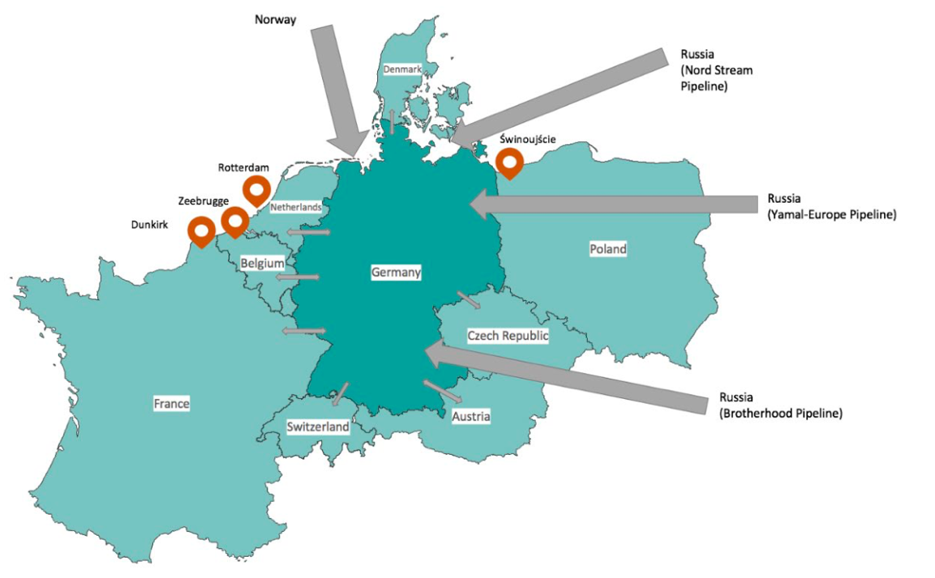
Map 1: Natural gas import connections to Germany
Source: https://www.diw.de/documents/publikationen/73/diw_01.c.839509.de/diw_focus_7.pdf, p.3

A special relationship between Vladimir Putin and German Chancellor Gerhard Schroeder is another crucial moment in the countries’ relations. Shortly after Schröder announced his retirement from politics, at the request of Putin, he was swiftly appointed as the chairman of the Nord Stream offshore natural gas pipeline.

Following Putin's reelection in 2012, the perception of Russia among the German media and the public began to shift in a negative direction. On the official level, one of the last attempts for cooperation has been Germany and France playing a key role in the Minsk II agreement reached in February 2015, aimed at achieving a ceasefire and implementing conflict resolution measures in eastern Ukraine. Chancellor Merkel and President Putin were personally involved in shaping the agreement. Nevertheless, the Nord Stream 2 gas pipeline is said to be conceived at a 70th birthday party for Schröder in St Petersburg in the spring of 2014, only weeks after the seizure of Crimea.

Moreover, Germany has continued to import gas from Russia via existing pipelines at historically high volumes. The economics ministry stopped publishing data on gas imports in 2016. In 2022 it was revealed that Russia’s share of German gas imports amounted to 55 per cent. The countries’ business ties in the energy sector even managed to develop in 2017, when Rosneft, Russian largest oil company, officially formed its own shareholding in the German refining business, controlling 12% of the country’s fuel production capacities. Gerhard Schroeder also took the position of the head of Rosneft's board in 2017.

The disruption
Since Russia invasion of Ukraine, the EU has been coordinating in close cooperation to react collectively against Putin’s actions. As of today, the EU has imposed 10 packages of sanctions with the main goal to weaken Russia's capacity to fund the war in Ukraine, impose penalties on the country's elite, and cripple Russia's economic foundation. These sanctions have been enforced on various sectors such as finance, energy, transport, and technology exports. The energy sector has specifically been targeted with sanctions that encompass a range of measures, and interruptions in energy supply.

Alternatively, the war's most immediate impact is felt in Germany's trade and investment with Russia and Ukraine. In 2021, Germany exported goods worth €27 billion to Russia and invested a total of €25 billion. As a result of Western sanctions, proactive withdrawal of German businesses, and a recession in Russia, exports are expected to plummet, and many investments will be lost. Per instance, the completion of the controversial $11 billion North Stream 2 energy project in September 2021 did not lead to its operation as Germany halted its approval in response to the invasion [3]. The pipeline runs parallel to the Nord Stream 1 pipeline, which has been operational since 2011. If Nord Stream 2 became operational, it would have doubled Nord Stream system's total capacity from 55 BCM to 110 BCM annually. Russia's state-owned energy firm, Gazprom, owns the pipeline, with half of the cost financed by five European companies. Despite the European Union's goal of diversifying its energy sources, some European countries continued to rely on Russian gas, which made up 40% of EU natural gas imports in 2021. Although construction is complete, the certification process is still pending, and the German energy regulator suspended it in November 2021. German Chancellor Olaf Scholz's withdrawal of a binding opinion in February 2022, halted the certification process.

Furthermore, on May 11, 2022, Russia sanctioned Gazprom Germania, which has been managed since April 2022 under trusteeship by the German energy regulator (the Federal Network Agency). Gazprom Germania had previously accounted for approximately 4% of all German gas imports, but media reports indicate that the company was able to continue purchasing gas on the spot market instead. Last spring, the German government seized the company and put it in a trust, now renamed as Securing Energy for Europe (SEFE), becoming the sole owner and injecting 225.6 million euros to ensure its immediate survival. Uniper, which is Germany's largest gas importer, has also been affected by significantly reduced gas flows from Russia. Therefore, the German state has agreed to provide a 15 billion Euro rescue deal and buy out the remaining 56% stake of Finland's Fortum for an additional 500 million euros.

According to research institutes, the consequences of this geopolitical disruption will cost Germany approximately €220 billion. The Bundesbank estimates losses of €165 billion this year and €115 billion in each of the following years. The central bank predicts that the most severe damages will result from higher commodity costs. Gas prices on the spot market have increased tenfold year-on-year. The resulting increase in electricity and gas costs for industrial processing is rendering certain economic activities economically unviable. The prices of goods in Germany have increased by approximately 7.6% compared to the previous year. This has also led to a rise in the prices of gasoline and diesel, which have now surpassed €2.00 per litre as of April 2022. As a result, the cost of living has increased, affecting everyday expenses like grocery shopping, transportation, dining out, etc. This is especially hard for lower-income groups, including students who are now forced to cut down on optional expenses.

"The war in Ukraine puts an end to the German economic business model as we knew it - a model which was mainly based on cheap energy imports and industrial exports into an increasingly globalised world."– this is one of the many similar comments of the economy experts, made in the middle of 2022 when the first financial results of the German energy redeployment could have been assessed. Of course, the impact of energy supplies from Russia on the functioning of German production can hardly be overestimated. One of the most vivid examples: BASF, a major German chemicals company, will eliminate up to 2,600 jobs globally due to cost pressures from the energy crisis. The majority of the job cuts will take place at the company's headquarters in Ludwigshafen, Germany, where it plans to close several energy-intensive production lines, including ammonia and associated fertilizer production, to adapt to changing conditions. The company, which is among Germany's largest individual gas consumers, announced last year that it would aim to reduce costs by 500 million euros per year by 2024 due to soaring production costs resulting from the energy crisis.

To address this issue, the German government has announced two aid packages: a 65 billion euros package to help households keep warm during winter, which includes a 2000 euros energy check for students, a 300 euros benefit for retirees, and an 80% energy bill subsidy. Following with 200 billion euros package which includes a 70% energy bill subsidy at 0.07 euros/KWh for 25000 large companies, 2000 hospitals, and all schools.

On the other hand, The European community has been critical of the German decision to provide 265 billion euros in subsidies to households and businesses. This move, referred to as a "double ka-boom," has stirred controversy due the excessive size of the package when compared to other countries in the European single market.

Internal tensions

The current Germany’s government coalition is considered by political experts as designed to be Germany’s most progressive government in a generation. In December of last year, Olaf Scholz took the oath as the Chancellor of Germany, leading an unparalleled tripartite coalition between the Social Democrats, Greens, and Free Democrats, which pledged to provide a "new beginning" following Angela Merkel's sixteen-year rule. However, a year after the coalition was formed, its aspirations have been completely overshadowed by the Ukrainian conflict and the resulting energy emergency, financial turmoil, and the need for reshuffling its policy priorities.

With the three mitigation packages, the new government had to take on about half a trillion euros of new debt. For the fiscally conservative Free Democrats (FDP) led by the country’s Finance Minister Christian Lindner, the rise in expenditure represents a potential substantial increase in Germany’s government debt and represents a crucial issue. The Greens had other compromises to deal with: they had to concur to reactivate coal-fired power plants and extend the lifespan of Germany's remaining nuclear reactors for an additional three-and-a-half months. Core matters for parties had to be renegotiated, all the while maintaining their governmental duties. As a result, Scholz, in an uncommon occurrence within German politics, had to exercise his power as Chancellor in October 2022 to settle a disagreement between the Greens and FDP concerning the future of nuclear energy. Additionally, the two parties clashed on the issue of a contentious fee imposed on gas consumers, intended to rescue gas importers like Uniper, which was introduced by the economy ministry of Greens, Robert Habeck. The disagreement persisted until the nationalization of Uniper and the abandonment of the fee proposal.

Some other internal political processes in the country cause even more concerns: The Alternative for Germany (AfD), the far-right party has once again altered its priorities since 2013, with its adherents gathered between the Reichstag and the chancellery in the heart of Berlin in October 2022, in the name of "energy security" and the "battle against inflation." The party officials have been advocating that Germany would greatly benefit from moving towards Moscow. "Let’s get rid of the sanctions!" Tino Chrupalla, president of the AfD, said, explaining that "the price of gas will return to normal when we buy cheap gas from Russia again."

Experts generally warn that amid the ongoing energy crisis in Germany, there is a risk of Russia exploiting concerns over rising prices and gas shortages in order to incite social unrest. The leftist party, Die Linke also took the chance to organize protests demanding that the government tackle the soaring inflation and skyrocketing energy prices. In 2022 Sahra Wagenknecht, a Die Linke politician and member of the left-wing Bundestag, criticized the government for engaging in an economic conflict with Russia as the Germany's primary energy provider. During her address to the Bundestag, she highlighted the detrimental effects of the Russian sanctions on Germany and urged for the cancellation of restrictions and engaging in talks with Moscow.

The Greens, under the leadership of Economics Minister Robert Habeck, were more inclined to confront the Kremlin due to their commitment to human rights. The move away from fossil fuels to renewable energy, achieved impressively within a year, was a positive step towards decoupling from Russia. However, this came with a considerable trade-off: a temporary return to coal mining and nuclear power, and the necessity of procuring liquid natural gas from Qatar and Saudi Arabia. The Free Democratic Party (FDP), despite their adherence to a free-market ideology and aversion to debt, unexpectedly found themselves endorsing substantial emergency spending measures, including a €200 billion offset package to support German businesses and consumers, in response to the Russian energy embargo. Christian Lindner, the party’s leader and current finance minister, backed these measures.

The redeployment

The natural gas crisis

The German government's dependence on Russian natural gas has led to concerns about the country's energy security and political stability, as Russia has demonstrated its willingness to use its energy resources as a tool for political leverage. Germany is looking today at mitigation measures to reduce reliance on Russian imports. However, this could prove difficult given that 95 % of the German natural gas is imported. As of 2020, more than 50 billion cubic meters of natural gas, half of the imports, have come from Russia. Today, no gas is being imported from Russia.

To mitigate these challenges effectively, the German government introduced some long-term strategies such as investing in permanent land-based LNG terminals, however a big LNG import terminal takes around five years to be built and become operational and requires very substantial investments. This means that the LNG projects starting now may not be operational until 2027. In addition, the German government plans to lease Floating Storage and Regasification Units in the short term, three of which were installed by winter 2022/23. The ministry stated last January that a total of 10 projects for direct LNG imports to Germany are under development. To speed up the permit and construction process, the government introduced an “LNG Acceleration Act”. It allows the licensing authorities, under certain conditions, to temporarily waive some procedural requirements, especially in the area of environmental impact assessment.

In recent years, The U.S. and Qatar has been the main driver of LNG growth. As for November 2022, Qatar Energy and ConocoPhillips (COP.N) have signed two sales and purchase agreements for the export of LNG to Germany for at least 15 years. In the same context, Germany is also sourcing more gas from Norway, and France. The export of Norwegian pipeline gas saw a 3.3% increase in 2022, while in the case of France, the country has agreed to deliver gas in exchange of electricity.

Nuclear Energy revival?

As a one of most reliant European member country on Russian energy, Germany was directly impacted by the crisis, and its government faced mounting pressure to respond to what many saw as an existential threat to the domestic energy security. This geopolitical scenario has led Germany to reconsider its total phase-out action plan for nuclear energy by the end of 2022, which was initiated following the nuclear consensus, in the governance of SPD and the Greens, in 1998 and accelerated in 2011 after the Fukushima’s disaster. As of last year, only three nuclear power plants are in operation, with a scheduled shutdown by the end of 2022. At the heart of any discussion around nuclear energy are issues such as safety precautions, waste management, and plant decommissioning processes.

With the increase of gas prices, sanctions on Russian energy exports, and panic among citizens about their ability to heat their homes during the winter, keeping nuclear power plants operational didn’t seem as unfavorable at a certain point. Robert Habeck, leader of the German Green Party, who had to reconsider his political stance faced with the energy crisis, initially expressed openness to the idea but later reversed his stance in March 2023. Shortly after, there were further deliberations to assess the feasibility of prolonging the lifespan of nuclear energy. Given that it only constitutes 6% of Germany's electricity, which is considerably lower than the 15% obtained from Russia's natural gas imports, it was determined that Germany would adhere to its nuclear phase-out plan but only postpone it just after the end of winter 2023.

Oil: crude awakening

The European Union's measures to restrict seaborne exports of Russian oil came into effect on December 5, 2022. These measures have been a crucial element of the EU's strategy to prevent Russia from acquiring billions of dollars in revenue to fund its military operations against Ukraine. Hungary, Slovakia, and the Czech Republic negotiated temporary exemptions from the embargo because they heavily rely on the Druzhba pipeline that directly connects to Russia. However, even though two eastern refineries, PCK Schwedt and Leuna in Germany, are also connected to Druzhba, Berlin has confirmed that it will enforce the embargo entirely by the end of 2023, with no exceptions.

The primary complication with PCK arises from the fact that the ownership of the refinery is Russian, with most of its shares being controlled by Rosneft. According to the German Energy ministry, this left little incentive for the company to process crude oil from alternative sources. PCK, the largest employer in Schwedt with a workforce of 1,200, has numerous supporting services that provide pipeline, heat exchanger, pump, and cooling unit manufacturing for the refinery. A significant concern among the community in Schwedt was that PCK may be forced to cease operations in the event of losing access to Russian crude oil.

After several months of negotiations between Berlin and Warsaw to secure supply for the Schwedt refinery, confirmation of commercial crude oil deliveries was obtained from the Polish port of Gdansk. At the same time, Kazakhstan agreed to supply 100,000 tons of oil via Druzhba to Germany to support the supply later in 2023. The oil will be supplied to Rosneft Deutschland, the Rosneft subsidiary that owns the refinery share and which Germany had put under a trusteeship of the German industry regulator in September 2022. Rosneft technically still holds 54.17% of the refinery while the management of the assets in Germany is organized by the trustee, the federal Network Agency of Germany.

Coal: the cost of the gas cut-off

Following the outbreak of hostilities between Russia and Ukraine that caused widespread destruction through Europe's natural gas transmission networks has forced Germany cut-offs from supplies by up-to-70%. This left many factories without heat or utilities using coal plants which led to significant increase in carbon emissions in cities like Bremen and Hamburg.

Already in the first half of 2022 Germany generated 82.6 billion kilowatt-hours of electricity from coal indicating a 17 percent increase from the corresponding period last year. This development has led to a nearly one-third increase in Germany's electricity generation from coal-fired plants, from 27 percent in the previous year. By the end of 2022, according to the Federal Statistical Office, exactly one third (33.3 percent) of the electricity generated in Germany and fed into the grid came from coal-fired power plants. In 2021, the proportion was still 30.2 percent. Electricity generation from coal thus increased by 8.4 percent over the year.

These data underscore the formidable task that the German government faces in achieving its clean energy objectives, as the country has been endeavouring to decrease its dependence on coal, which emits nearly twice as many greenhouse gases as gas and over 60 times that of nuclear energy. German plans before 2022 included becoming carbon neutral by 2045 and stopping burning coal, gradually phasing out its coal-fired plants by 2038.

To compensate for the unexpected increase in coal production, the government cut a deal with energy company RWE to move the coal phaseout deadline in Nordrhein-Westfalen, a major coal-producing region, to 2030.

Renewable Energy: creating the base for the future
In the face of energy supply disruption and in order to find medium term alternatives, the government increased investments in renewables and initiated emergency measures to stabilize both electricity supply and prices. Renewable energy has been a major focus for Germany in recent years, with the government setting ambitious targets to increase renewable energy usage and decrease dependence on fossil fuels. However, the Russian-Ukraine War in 2022 had a significant impact on Germany's renewable energy development. Before the conflict, Germany was leading Europe in renewable energy, making substantial progress towards its goal of achieving an 80% reduction in GHG emissions and 100% renewable electricity supply by 2050. Per instance, it is one of the largest solar power producers in the world, with an installed capacity of 60-gigawatts, the country is ranked 4th globally in 2021. This was due to numerous policies and initiatives such as feed-in-tariffs and investment subsidies which encouraged the expansion of renewable energy production capacity across wind, solar photovoltaic (PV), biomass, and hydropower technologies. Notably, Germany's wind energy sector accounted for over half of its total renewable electricity generation, making it one of the largest producers of wind power globally, in 2022.
Against this backdrop, the Minister of Economics, Robert Habeck, introduced the "Easter package," which is the first extensive package of laws designed to establish the necessary conditions for Germany's energy transition with the goal to achieve at least 80% of gross electricity consumption from renewables by 2030 . This led to extensive amendments to the German Energy Industry Act (EnWG), the German Renewable Energy Sources Act (EEG), and the German Offshore Wind Energy Act (WindSeeG). However, an earlier proposal to reach 100% renewables by 2035 was dropped during final deliberations.

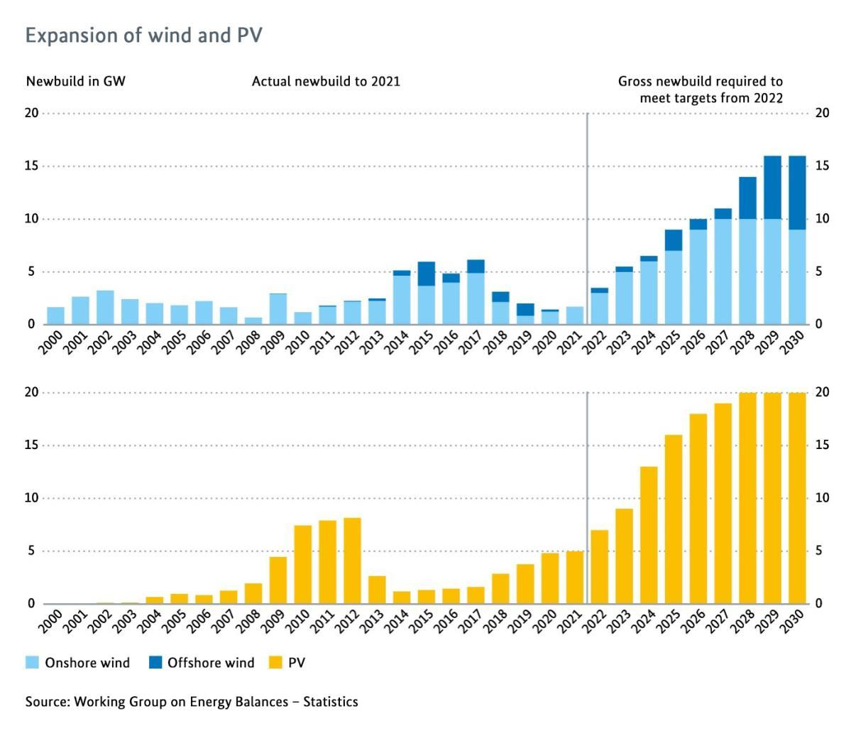
Figure 2: Expansion of wind and solar
Source: https://www.bmwk.de/Redaktion/EN/Downloads/E/germany-s-current-climate-action-status.pdf?__blob=publicationFile&v=1, p. 13
To meet this target, Solar capacity is expected to increase from 59 GW to 400 GW by 2040, with auction volumes for solar freestanding installations set to be 5,850 MW for 2023, 8,100 MW for 2024 and 9,900 MW annually from 2025 to 2029. Auction volumes for offshore wind energy range between 8,000 and 9,000 MW for 2023 and 2024, and between 3,000 and 5,000 MW for 2025 and 2026, increasing to 4,000 MW annually from 2027. The auction volume for onshore wind energy has also been raised to 12,840 MW for 2023 and 10,000 MW annually from 2024 to 2028, with any quantities not awarded being put up for tender the following year.

Furthermore, as the German government has been taking significant steps towards increasing investments in renewable energy sources to achieve energy independence in response to recent challenges in the electricity supply and pricing, emergency measures were implemented to stabilize the energy sector. These measures involved harnessing existing power storage technologies, such as batteries, and leveraging pumped hydroelectric reservoirs.

The wind industry faced a setback during a disruption in gas supply as it heavily relied on natural gas for backup power during periods of low wind. To tackle this issue, Germany has proactively installed more battery energy storage systems, providing an alternative and reliable source of backup power. However, the government recognizes that the future requires more comprehensive and sustainable solutions to ensure energy independence. As a long-term measure, Germany is shifting its focus towards the production of hydrogen from renewable sources, such as photovoltaic and wind technologies. This move aims to foster a greener approach, reducing reliance on imports from unreliable neighboring countries, as Russia.

Regarding hydrogen, the German government is taking proactive steps to accelerate the growth of the global hydrogen economy and establish stronger partnerships with emerging and developing countries. To provide financial support for these initiatives, the government plans to set up two funds, with a total of 550 million euros. These funds will be allocated to various projects and collaborations aimed at promoting the adoption and utilization of hydrogen on a global scale. Germany's approach also involves establishing "hydrogen diplomacy" offices in countries with significant hydrogen potential, such as Saudi Arabia and Nigeria. These offices will facilitate cooperation and foster partnerships to promote the import of green hydrogen (GH2) products from these nations. Furthermore, Germany has signed two declarations of intent with Egyptian ministers to strengthen cooperation in the development and utilization of green hydrogen and liquefied natural gas (LNG) and has also made arrangements to receive initial deliveries of hydrogen from Canada, with scheduled shipments set to commence in 2025. This signifies Germany's determination to secure a diverse and reliable supply of hydrogen for its domestic consumption and contribute to the growth of sustainable hydrogen markets globally.

In summary, for Germany to attain full energy independence and depend solely on renewable energy, substantial investments are imperative to upgrade and expand its energy grid infrastructure as well as its storage facilities.

Conclusion

Right after the start of the war in 2022 German Chancellor Olaf Scholz called the developments the Zeitenwende, or historical turning point. A year after it is safe to say that Scholz can be credited with successfully reshaping Germany's national discourse on strategic matters. The government has acknowledged the shortcomings of its Russia policy, which it had maintained for a long time. In response to the invasion, Berlin halted the construction of Nordstream 2, a gas pipeline to Russia, as well as implemented a whole range of measures including stopping strategic oil supplies that seemed to be an impossible task to do before 2022. Albeit those measures came at the cost of all three parties of today’s German government shedding some of their fundamental beliefs.

That said, the developments are tangible, and it might seem that the path dependency of the strong energy ties with Russia formed by the last 40 years starts to change. Nevertheless, Scholz's administration is still not adequately equipped to confront all the upcoming issues, let alone position Germany for a future fraught with persistent upheaval. Winter 2023-2024 brings uncertainty in gas supply while the industry struggles with energy prices have just begun with the concern now being that industrial production could, in the long term, shift away from Germany altogether. After all, even the strongest, most influential members of the EU cannot conduct a purely national foreign policy and Germany’s decisions in the energy crisis came at cost of discontent and risk for other EU countries.

What is needed, therefore, is a commitment to re-evaluating Germany's energy policies, institutions, and procedures, and a sense of urgency that corresponds to the magnitude of the task at hand. The country also must recognize that Europe's security is highly contingent on Germany's economic response to this crisis, and that it plays a central role in this regard. Finally, it’s extremely important to take measures to solidify international relations with a variety of partners in order both to exclude new dependencies and ensure energy transition for decades to come. Only that way a real Zeitenwende can be achieved.

Clean Energy Wire, Germany, EU remain heavily dependent on imported fossil fuels, 2023, https://www.cleanenergywire.org/factsheets/germanys-dependence-imported-fossil-fuels#four
Deutsche Welle, What's behind eastern Germans' empathy for Russia?, 2022, https://www.dw.com/en/whats-behind-eastern-germans-empathy-for-russia/a-61954976
Reuters, Germany freezes Nord Stream 2 gas project as Ukraine crisis deepens, 2022, https://www.reuters.com/business/energy/germanys-scholz-halts-nord-stream-2-certification-2022-02-22/
Reuters, Germany's Uniper gets 1.5 bln euro state bail-out to avert collapse, 2022, https://www.reuters.com/markets/deals/germanys-uniper-gets-15-bln-eur-state-bail-out-avert-collapse-2022-07-22/
Jana Randow, Aljazeera, Germany faces recession if war in Ukraine spurs energy ban, 2022, https://www.aljazeera.com/economy/2022/4/22/germany-faces-recession-if
The Economic Times, “Germany's economic model shaken by energy crisis”, 2022, https://economictimes.indiatimes.com/news/international/business/germanys-economic-model-shaken-by-energy-crisis/articleshow/93208928.cms?utm_source=contentofinterest&utm_medium=text&utm_campaign=cppst
Bundesministerium der Finanzen (federal ministry of finance, Germany), Schnelle und spürbare Entlastungen in Milliardenhöhe, 2022, https://www.bundesfinanzministerium.de/Content/DE/Standardartikel/Themen/Schlaglichter/Entlastungen/schnelle-spuerbare-entlastungen.html
Deutsche Welle, Far-right AfD seeks a boost in times of crisis, 2022, https://www.dw.com/en/germanys-far-right-afd-hopes-for-a-boost-in-times-of-crisis/a-63252759
Reuters, Qatar Energy, ConocoPhillips sign LNG supply deal with Germany, 2022, https://www.reuters.com/business/energy/qatarenergy-conocophillips-sign-lng-supply-deal-germany-2022-11-29/
European Commission, Germany’s Long-term Strategy under the Paris Agreement, 2019, https://ec.europa.eu/clima/sites/lts/lts_de_en.pdf
Clean Energy Wire, Germany plans additional €550 million for green hydrogen cooperation, 2022, https://www.cleanenergywire.org/news/germany-plans-additional-eu550-million-green-hydrogen-cooperation
Clean Energy Wire, Germany plans additional €550 million for green hydrogen cooperation, 2022, https://www.cleanenergywire.org/news/germany-plans-additional-eu550-million-green-hydrogen-cooperation
Clean Energy Wire, Germany plans additional €550 million for green hydrogen cooperation, 2022, https://www.cleanenergywire.org/news/germany-plans-additional-eu550-million-green-hydrogen-cooperation
APNews, Canada, Germany aim to start hydrogen shipments in 2025, 2022, https://apnews.com/article/russia-ukraine-canada-germany-justin-trudeau-48b1e11865de496fa05f53d09ecc5219

